**Game Output**

Main Menu

Game Menu 🡪 start the game where player can choose different modes of game

Quit 🡪 quit the game

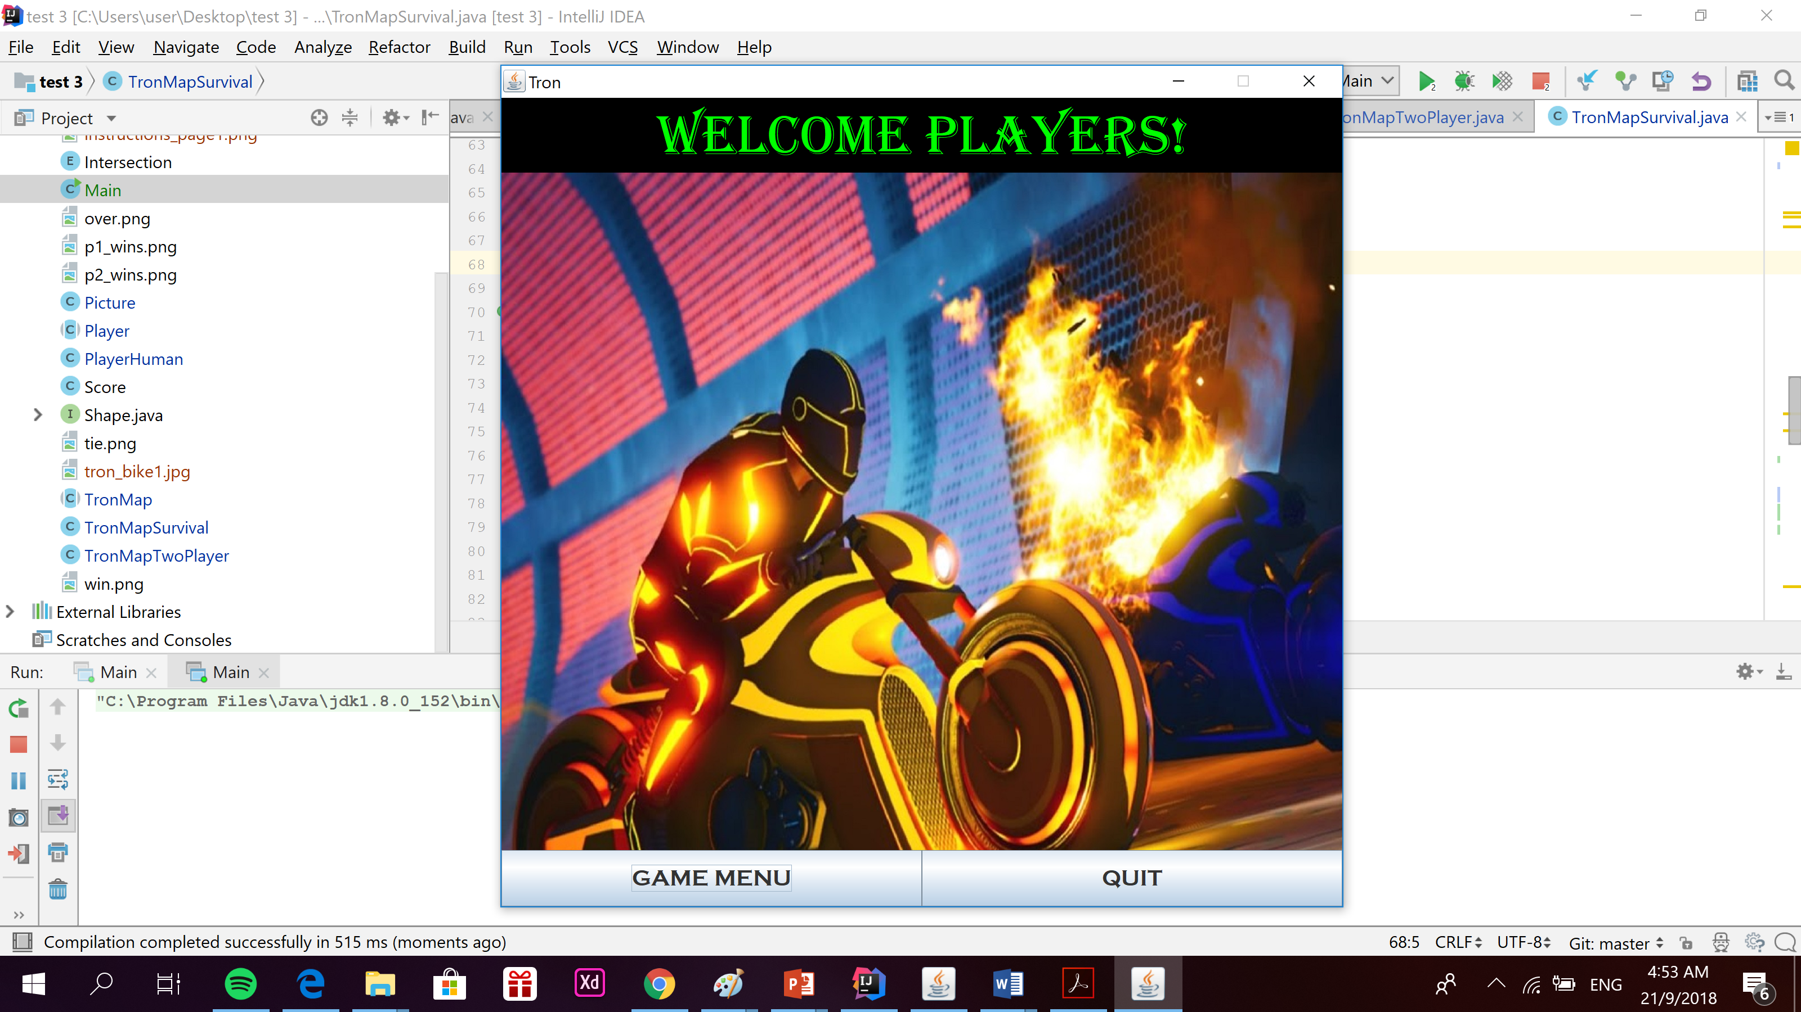

Main Menu

Single Player 🡪 Single player mode

Two Player 🡪 Two player mode

Highscore 🡪 see the high score for single player mode

Main menu 🡪 go back to main menu

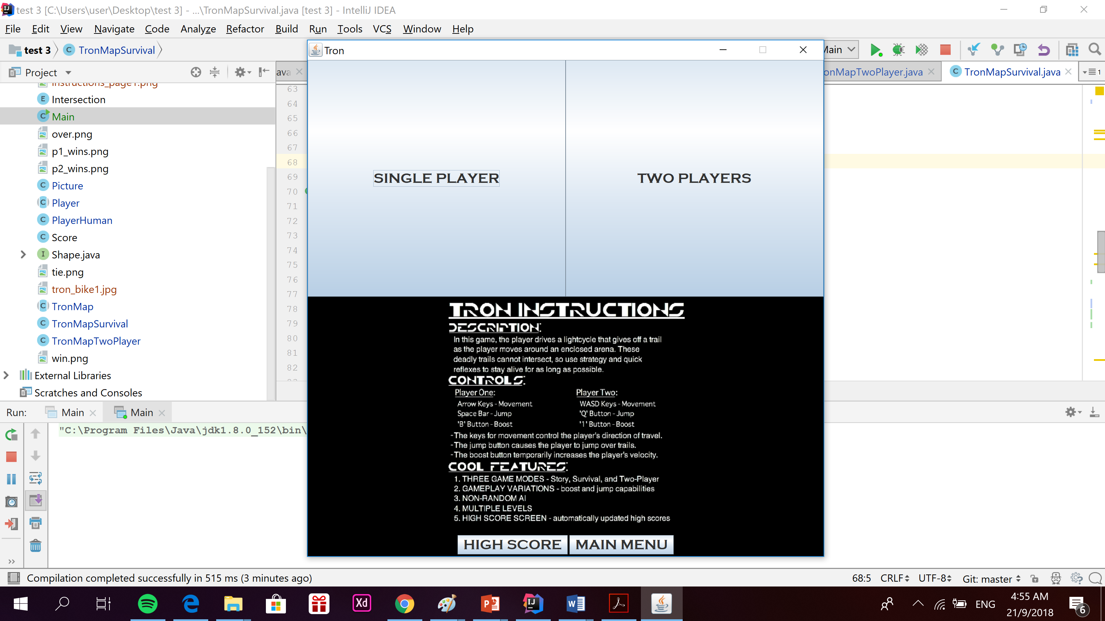

Single player mode

Restart 🡪 restart the game if the player loses

Game menu 🡪 return to the game menu

It also shows the score as the player moves

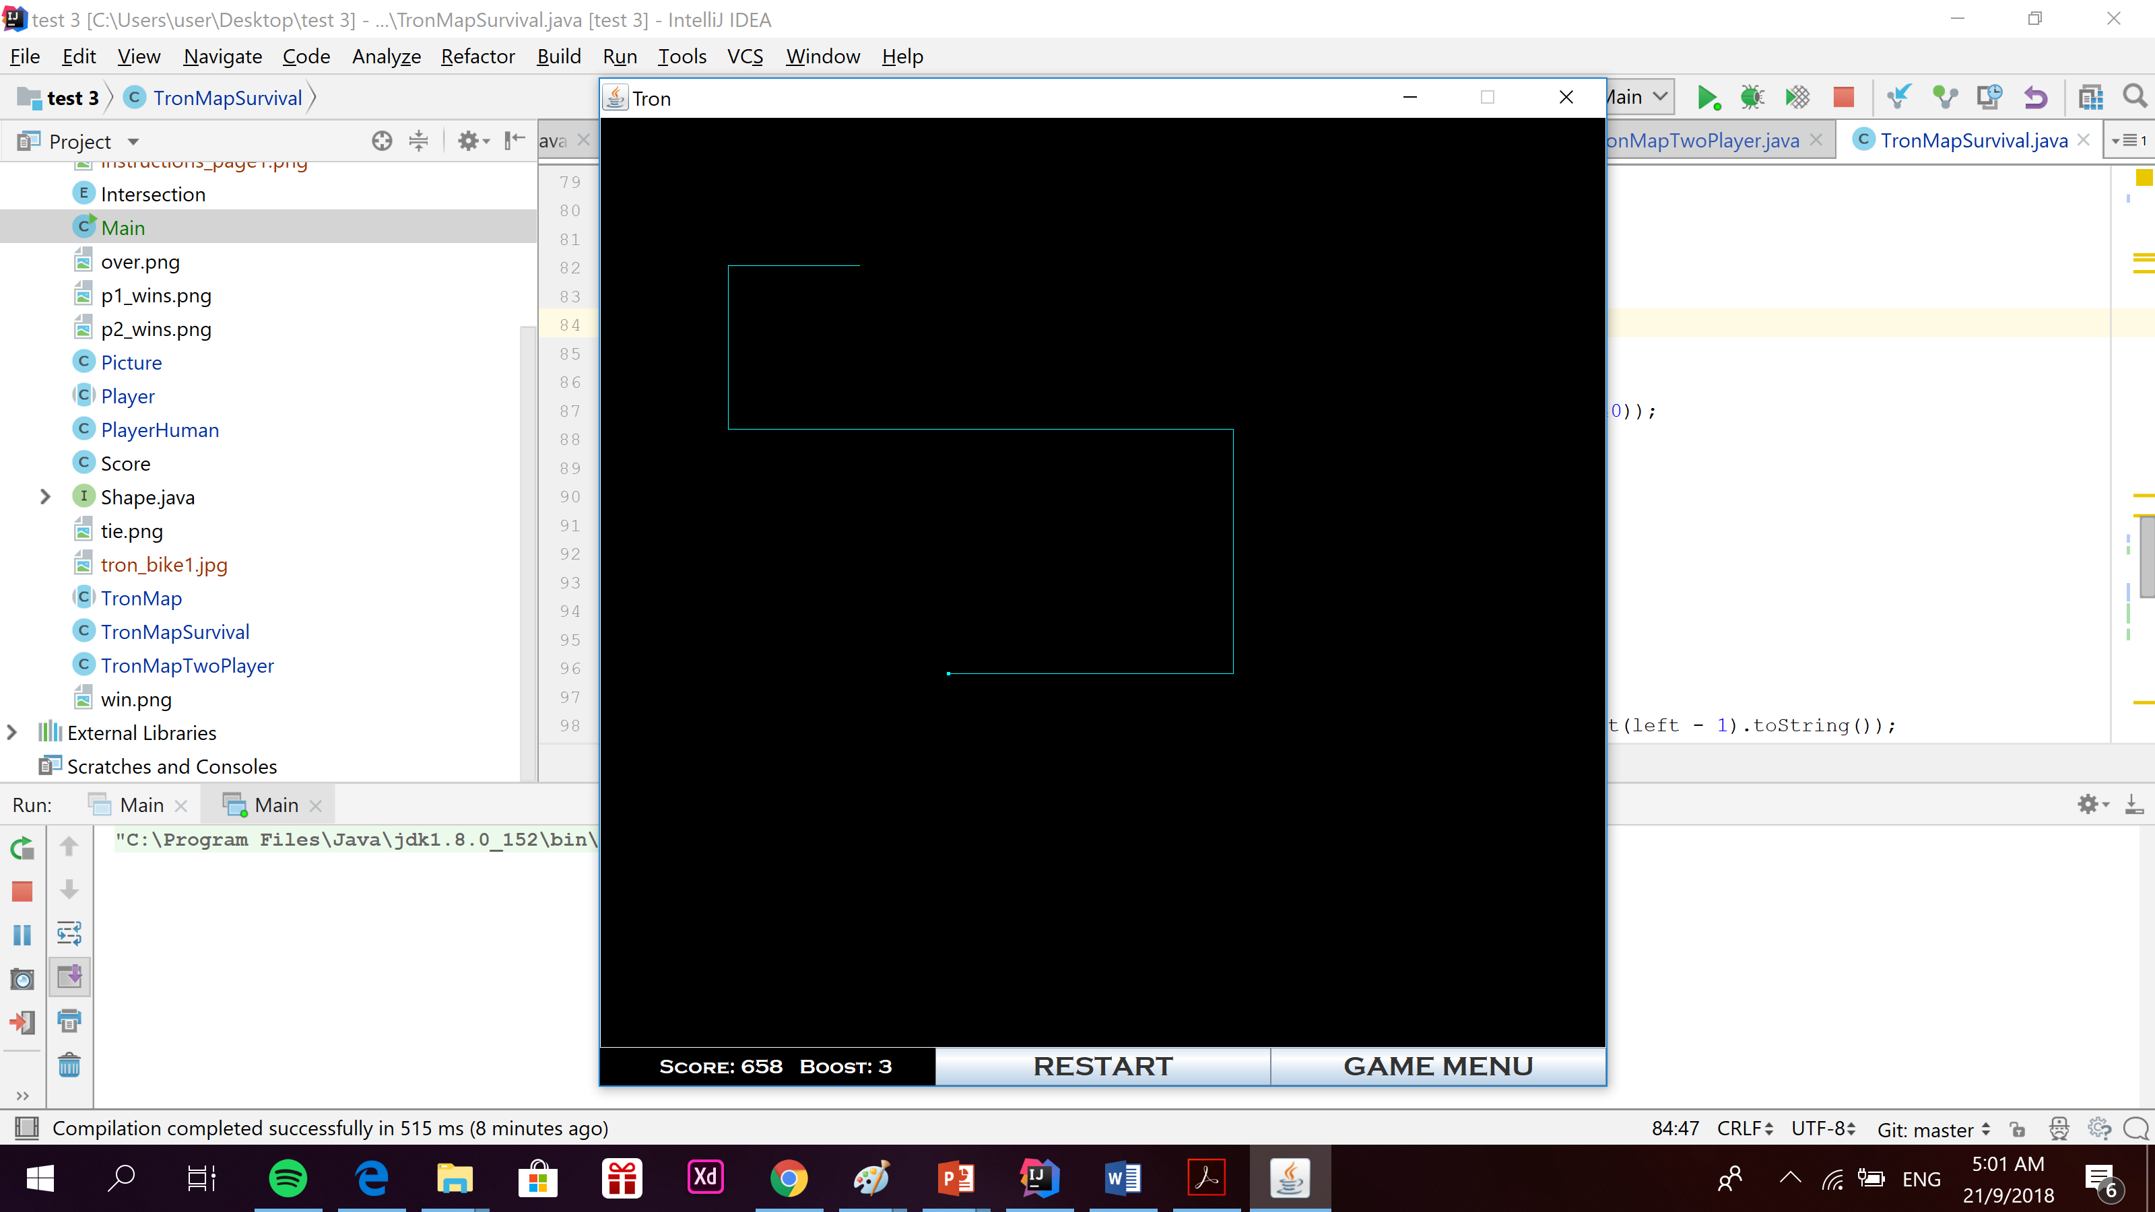

Game is over if the player hits the wall or itself.

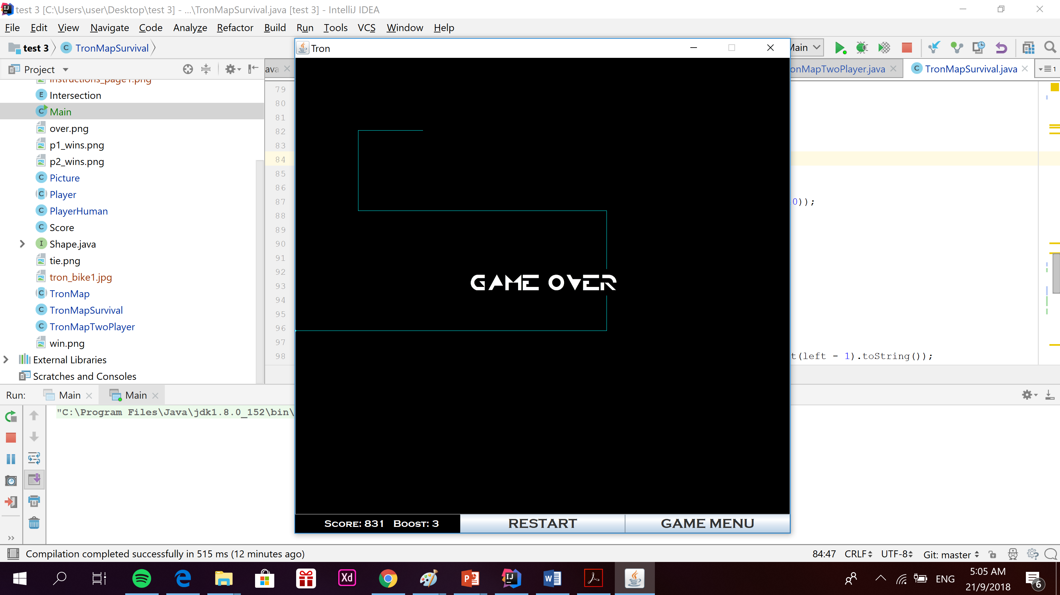

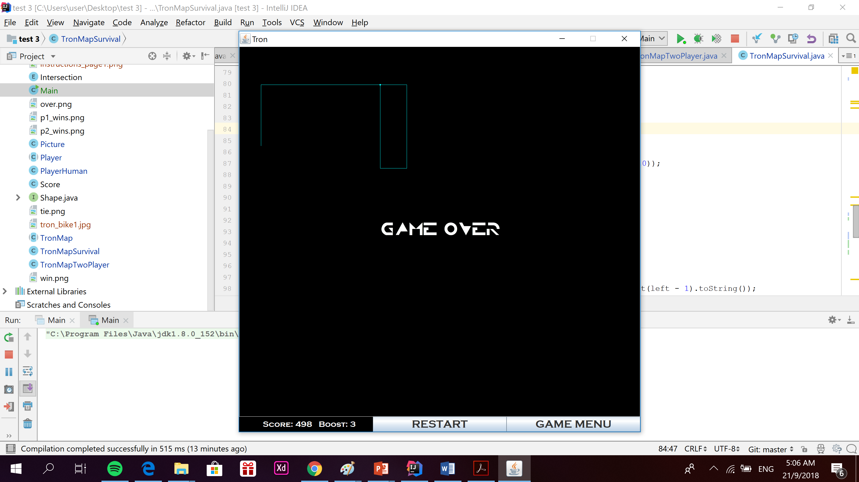

Two player mode

If either one of the players hit the boundaries, itself or the other player, they will be eliminated.

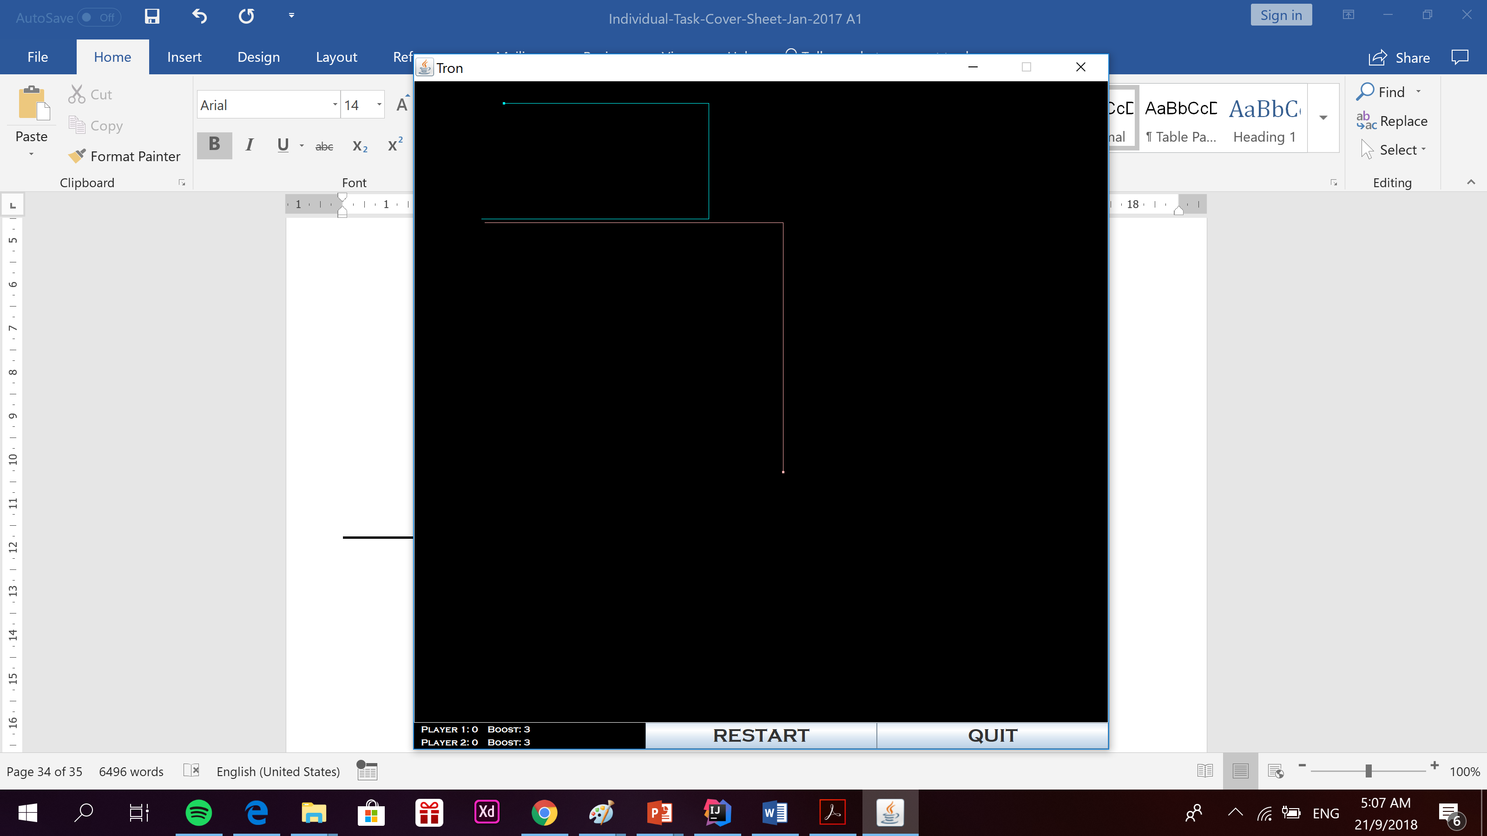

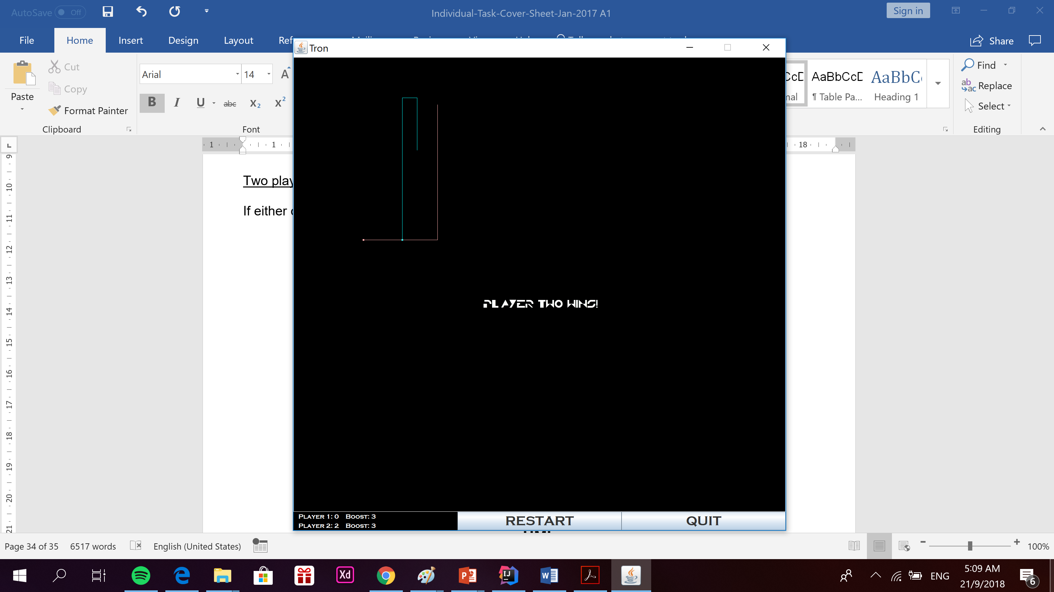

LeaderBoard

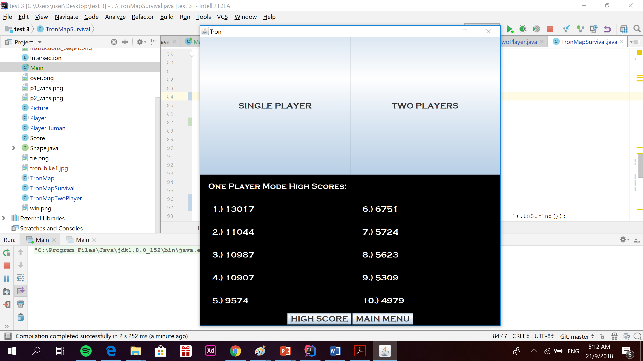

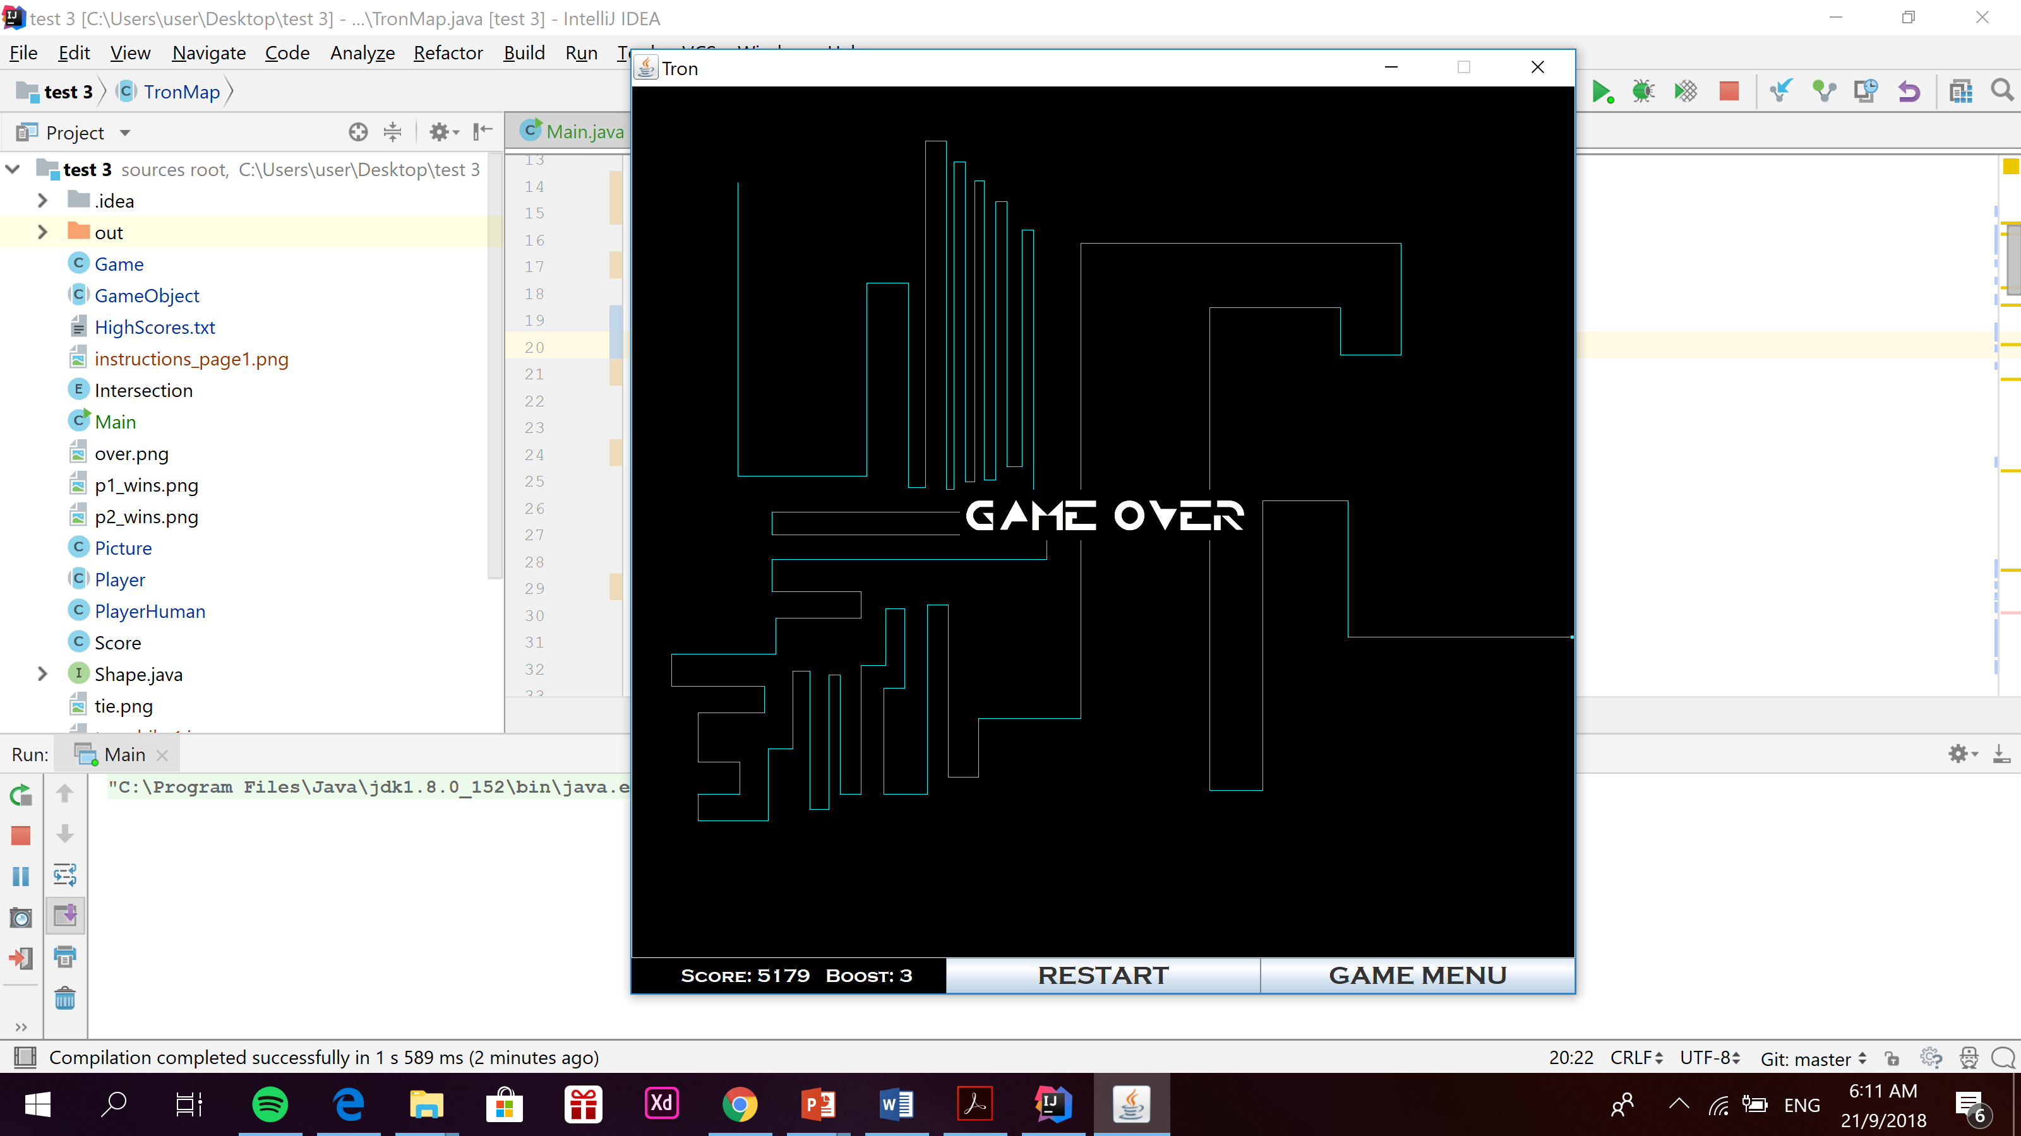

The leaderboard will update once the player leaves the game

